LAB EXPERIMENT 8
NAME:Furthose samreen B
REG NO:192511164
8.You are tasked with developing an online learning Platform.The Platform should include the following functionalities. Link Jira tasks with Confluence to streamline task tracking and progress monitoring for the Library Management System development.
- Create a new page in Confluence titled "Library Management System Project Overview."
- Embed at least 5 Jira issues related to the development of the Library Management System (e.g., tasks from the sprint like "Develop book search functionality," "Create user login page," etc.).
- Use the Jira macro to display issues with status (e.g., "To Do," "In Progress," "Done").
- Add a progress bar in the Confluence page to visually track the completion of each embedded Jira task (e.g., percentage of tasks completed in the sprint).
- Submit a screenshot of the Confluence page showing the embedded Jira tasks and the progress
AIM
To integrate Jira with Confluence for the Library Management System project to streamline task tracking, monitor development progress, and improve team collaboration.
PROCEDURE
- Open Jira and create a project named Library Management System.
- Create at least five Jira issues related to the project:
  - Develop Book Search Functionality.
  - Create User Login Page.
  - Design Database for Library.
  - Develop Book Issue and Return.
  - Create Student Registration Page.
- Open Confluence and create a new page titled Library Management System Project Overview.
- Type /Jira and select the Jira macro to embed the five Jira issues.
- Display the Jira issues with their task ID, description, and status (To Do, In Progress, Done).
- Add a progress bar to visually represent the completion of project tasks.
- Calculate the completion percentage based on the number of completed tasks.
- Publish the Confluence page and verify that all Jira issues and progress details are displayed.
- Take a screenshot of the completed Confluence page and submit it.
OUTPUT:
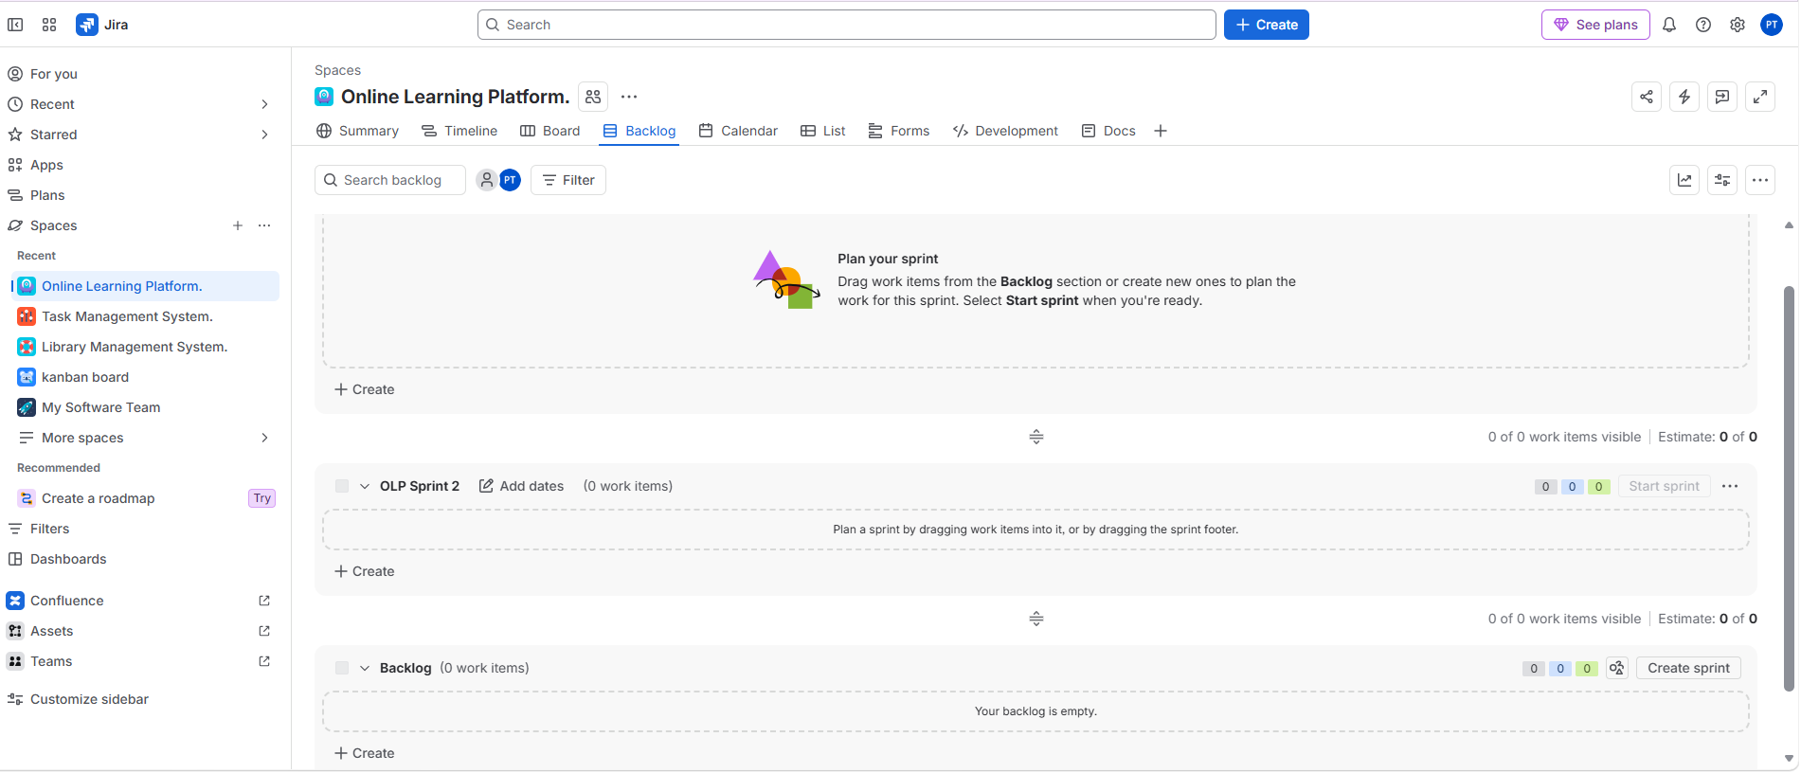
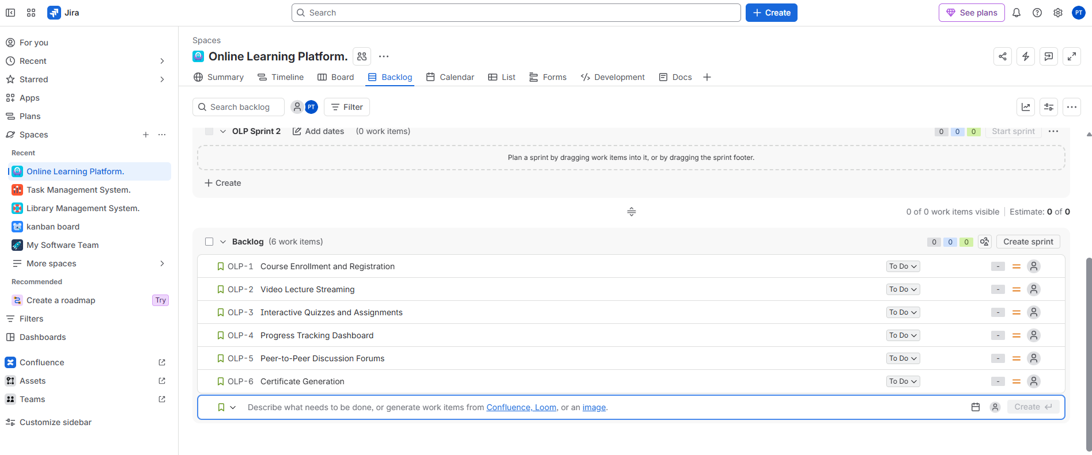
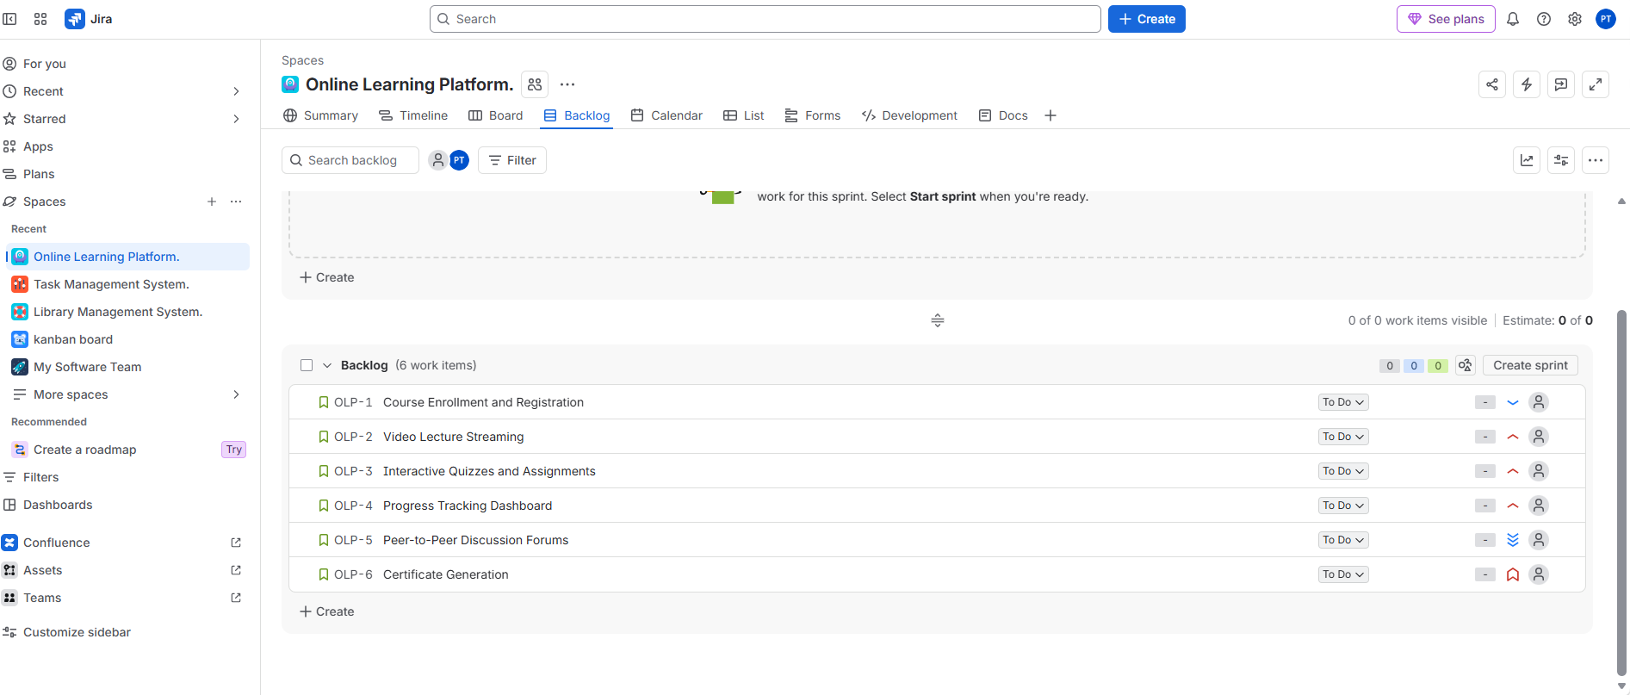
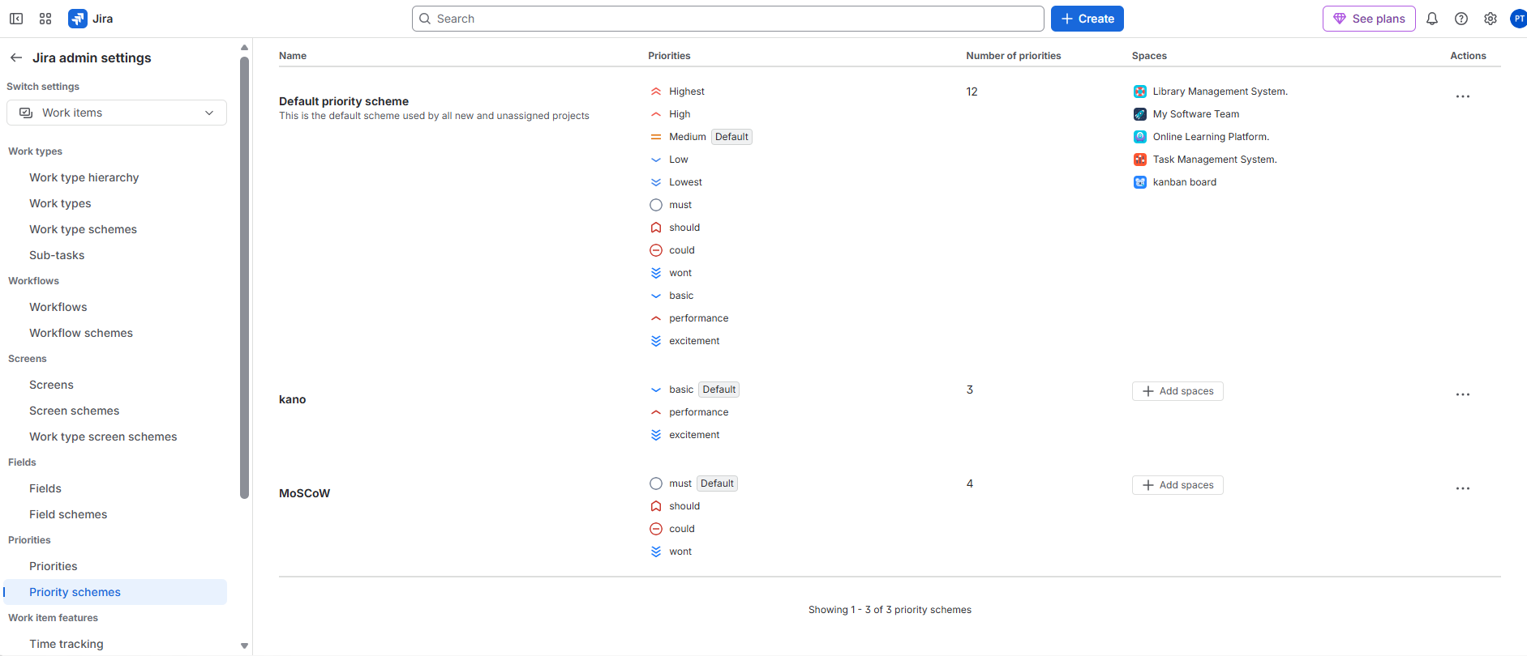
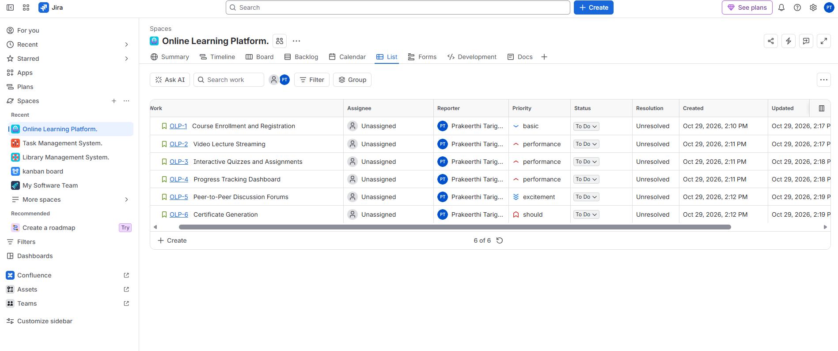

RESULT ;
Thus, Jira tasks were successfully linked with Confluence for the Library Management System project. Five Jira issues were displayed with their respective statuses, and a progress bar was added to monitor sprint completion. This integration helps improve task tracking, project monitoring, and team collaboration.

